St Gregory’s Newsletter – December 2025
St Gregory’s Church, Wellington Road, Bollington, Macclesfield. SK10 5JR.
Tel: 01625 572108 www.stgregorysbollington.org.uk Facebook: St GregorysBollington
Fr Martin Coyle SDB 07754 057074  frmartin@stgregorysbollington.org.uk | Parish Secretary: Liz Murphy  churchoffice@stgregorysbollington.org.uk
Fr Joe Tran SDB 07759 879663 | Safeguarding: Julie Taylor: 07963 406263

Jubilee Year 2025 – Pilgrims of Hope
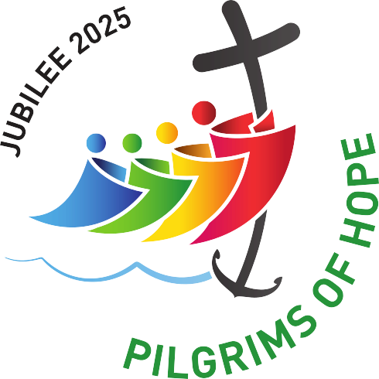
ADVENT
Advent is the beautiful season of waiting; waiting in anticipation, waiting in expectant fulfilment, and this year in particular, waiting in hope!
We might want to reflect on, ‘what are we really waiting on, what are we really anticipating, what are we really expecting to be fulfilled?
Advent Talk on Friday 5th December 10.30-11.20am
Fr Michael Winstanley will be giving an Advent talk in the church hall on Friday 5th December. Tea and coffee will be served from 10.15am and the talk will begin at 10.30am prompt to finish at 11.20am. There will be an opportunity for adoration at 11.30am and Mass at 12 noon for those who can stay on after the talk. All are welcome.
Reaching out to ROAR!
Over the last few years St Gregory’s parishioners have been very generous in raising money and sending Christmas gifts to ROAR - Reach Out And Recover - in Macclesfield. You will remember that ROAR is a not-for-profit, support in the community organisation, which offers people who face addiction, homelessness and other issues a safe, secure and stable environment in which they can start to tackle their addictions and personal issues. It is a housing project, and those who access the service are given help to take control of their lives and to develop practical skills whilst working in the community. It is noted for its high success rate.
I’m hoping to collect some Christmas gifts for them as we have in previous years. Things like hats, scarves, gloves, socks, slippers, chocolates, biscuits, and toiletries will be very welcome, so that they can have a gift at Christmas, and some of which they can share with local homeless or elderly people living alone nearby for whom they provide a Christmas lunch at the United Reformed Church. I will place a donation box at the back of church covering the first three weekends of Advent, 30th November, 6th/7th December and 13th/14th December. Please do not wrap the presents so that they can be easily allocated. For more information, contact me directly, and you can read all about ROAR on the display board in the church porch. Thank you so much. Cynthia Crewe: cynthia.crewe@virginmedia.com 07711570161
Christmas Raffle
Christmas Raffle tickets are on sale at the back of church; tickets are £1.00. The draw will take place in the hall on Sunday 21st after the Carol Service. Thank you to those who have generously donated prizes and to Liz for organising it. Please do all you can to make this a great success.
Parish House Renovation
Unfortunately, the Finance Committee of the Diocese have not approved the house renovation project or the money to complete it. This is very frustrating and disappointing after 4 years in the planning.
I suggest that, in the new year, we paint the ground floor of the house and return it to use for 1st sacraments and any other meetings for groups in the parish. Get you paint brushes ready!
Dates for your diary in December 2025:
The Pope’s Prayer intention for December is for Christians in areas of conflict.
Let us pray that Christians living in areas of war or conflict, especially in the Middle East, might be seeds of reconciliation and hope.
Thursday 4th: 3.00pm Divine Mercy Prayer Group Meeting in the Hall
Friday 5th: 10.15am Advent Talk in the hall by Fr Michael Winstanley SDB – see overleaf for details
6.00pm Youth Group at Savio
Monday 8th: Solemnity of the Immaculate Conception of the Blessed Virgin Mary
Tuesday 16th: 7.00pm Advent Reconciliation Service
Friday 19th: 6.00pm Youth Group at Savio

CHRISTMAS 2025 AT ST GREGORY’S
Sunday 21st: 6.30pm Carol Service and Benediction, followed by Mulled Wine and Mince Pies
Mon and Tues: 10.00am Mass
Wed 24th: Christmas Eve
4.00pm Children/Family Mass
10.30pm ‘Midnight’ Mass
Thursday 25th: Christmas Day
10.30am Christmas Mass
Friday 26th: 11.30 Adoration followed by 12.00 Mass
Saturday 27th: 6.00pm Vigil Mass
Sunday 28th: 8.30am and 10.30am Mass Feast of the Holy Family
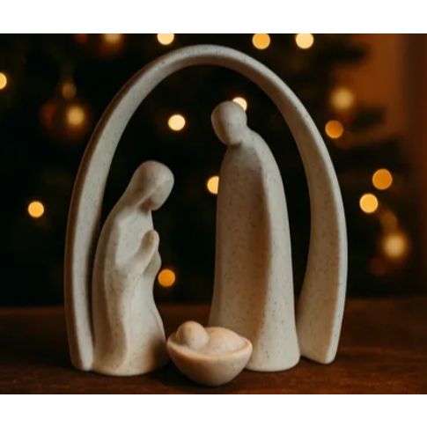
Looking forward to January 2026:
Thursday 1st: Solemnity of Mary, the Mother of God: 10.00 Mass
Tuesday 6th: Solemnity of the Epiphany of the Lord: 10.00 Mass, and the end of the Jubilee Year of Hope – but Hope lives on!
Sunday 11th: The Baptism of the Lord
Saturday 31st Feast of St John Bosco

